Decision tree neural network assignment

1. Summertime has passed, but the shore is still beautiful this time of year. This semester with online learning in full swing, brain power has gone to an all time low. You wish to let your your computer "think" for you on the weekend. Your weekend decision for next week is whether you should go to the beach or not. You decide to program your computer, using decision trees, so that it can make this all-important decision for you. Monitoring your past beach activity resulted in the following set of training examples:

|  |  |  |  |  |  |
| --- | --- | --- | --- | --- | --- |
| Day | Outlook | Temperature | Humidity | Wind | Go to beach? |
| D1 | Sunny | Hot | High | Weak | Yes |
| D2 | Sunny | Hot | High | Strong | Yes |
| D3 | Overcast | Hot | High | Weak | Yes |
| D4 | Rain | Mild | High | Weak | No |
| D5 | Rain | Cool | Normal | Strong | No |
| D6 | Rain | Cool | Normal | Weak | No |
| D7 | Overcast | Cool | Normal | Strong | No |
| D8 | Sunny | Mild | High | Strong | Yes |
| D9 | Sunny | Cool | Normal | Weak | Yes |
| D10 | Rain | Mild | High | Strong | No |
| D11 | Overcast | Hot | High | Strong | No |

a) Given the following formula for Entropy, replace the variables (pi ) in the equation with their appropriate values as given by the above table.



|  |
| --- |
| Entropy(Go to beach = Yes) = 5/11  Entropy(Go to beach = No) **=** 6/11  Entropy(S) = -5/11 log2 (5/11) - 6/11 log2 (6/11) |

b) (5 points) If Entropy (S) = .994 and the formula for Information Gain is:

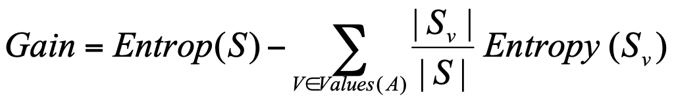

Entropy(Sunny) = 0

Entropy(Overcast) = .918

Entropy(Rain) = 0

|  |
| --- |
| What is the Information Gain for the attribute Outlook?  Gain = .994 – [(4/11 * 0) + (3/11 * .918) + (4/11 * 0)]  Gain = .744 |

c) You calculated the information Gain for each attribute and got the following results:

Gain (S, Humidity) = .151

Gain (S, Wind) = .048

Gain (S, Temperature) = .029

Gain (S, Outlook) = .744

Which attribute labels the root node of the decision tree?

|  |
| --- |
| Since outlook has the highest information gain (1.244), it would be labeled as the root node of the decision tree. |

d) The resulting decision tree is shown below.

Outlook

Overcast

Rain

Sunny

No

Wind

Yes

Strong

Weak

No

Yes

What are the rules for deciding to go to the beach?

|  |
| --- |
| if (Outlook = ‘Sunny’)  {return ‘Yes’;}  else if(Outlook == ‘Overcast’) {  if(‘Wind’==’Strong)  {return ‘No’;}  else if(‘Wind’==’Weak’)  {return ‘Yes’;}  }  else if(Outlook=’Rain’)  {return’No’;} |

2. A perceptron is given the following set of training examples.

|  |  |  |
| --- | --- | --- |
| x1 | x2 | result |
| 0 | 0 | 0 |
| 1 | 0 | 0 |
| 0 | 1 | 0 |
| 1 | 1 | 1 |

xo = 1

wo = .6

x1

w1 = .4

x2

w2 = .8

The equations for the Perceptron training rule is:

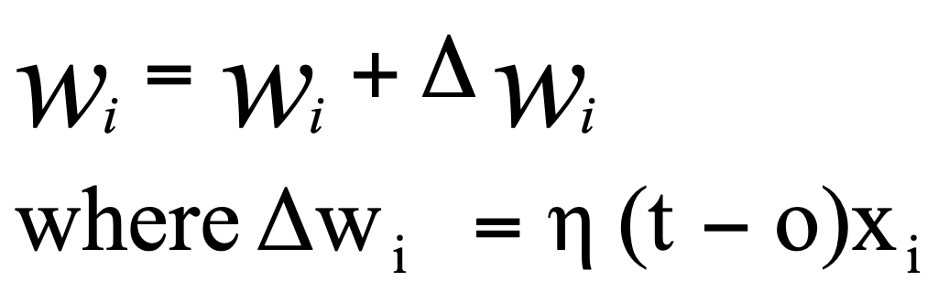

If h = **.**1 what are the values for w0 , w1 , w2  after one pass through the perceptron training algorithm?

$η$ = .1

t = result

o = output

|  |  |  |  |  |  |  |
| --- | --- | --- | --- | --- | --- | --- |
| x1 | x2 | result (t) | $$\sum_{i=0}^{3}{w_{ix_{i}}}$$ | output (o) | $∆w_{i}$ = $η \left(t -o\right)x_{i}$ | $∆w_{i}$ = $w_{i}$ + $∆w_{i}$ |
| 0 | 0 | 0 | 1(.6) + 0(.4) + 0(.8)  = .6 | 1 | $∆w_{0}$ = .1(0 – 1)1 = -.1 $∆w_{1}$ = .1(0 – 1)0 = 0 $∆w_{2}$ = .1(0 – 1)0 = 0 | $w_{0}$ =.6 + -.1 = .5 $w_{1}$ =.4 + 0 = .4 $w_{2}$ =.8 + 0 = .8 |
| 1 | 0 | 0 | 1(.5) + 1(.4) + 0(.8)  = .9 | 1 | $∆w_{0}$ = .1(0 – 1)1 = -.1 $∆w_{1}$ = .1(0 – 1)1 = -.1 $∆w_{2}$ = .1(0 – 1)0 = 0 | $w_{0}$ =.5 + -.1 = .4 $w_{1}$ =.4 + -.1= .3 $w_{2}$ =.8 + 0 = .8 |
| 0 | 1 | 0 | 1(.4) + 0(.3) + 1(.8)  = 1.2 | 1 | $∆w_{0}$ = .1(0 – 1)1 = -.1 $∆w_{1}$ = .1(0 – 1)0 = 0 $∆w_{2}$ = .1(0 – 1)1 = -.1 | $w_{0}$ =.4 + -.1 = .3 $w_{1}$ =.3 + 0 = .3 $w_{2}$ =.8 + -.1 = .7 |
| 1 | 1 | 1 | 1(.3) + 1(.3) + 1(.7)  = 1.3 | 1 | $∆w_{0}$ = .1(1 – 1)1 = 0 $∆w_{1}$ = .1(1 – 1)1 = 0 $∆w_{2}$ = .1(1 – 1)1 = 0 | $w_{0}$ =.3 + 0 = .3 $w_{1}$ =.3 + 0 = .3  =.7 + 0 = .7 |

3. Given the following simple two layer feed forward neural network, with two input, two hidden units and one output node, determine the output of the network if the weights are equal to the following values. The threshold function used by each unit is tanh. You only need to set up the equations. Do not solve them.

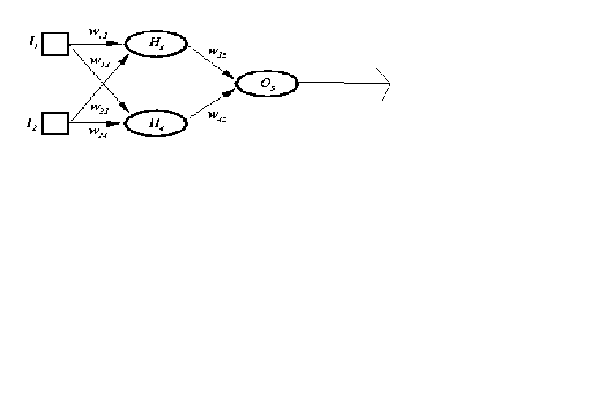

W13  = .4

W14  = .6

W23  = .3

W24  = .4

W35  = .4

W45  = .5

|  |
| --- |
| H3 = tanh(I1*w13 + I2*w23)  = tanh(I1*.4 + I2*.3)  H4 = tanh(I1*w14+I2*w24)  = tanh(I1*.6 + I2*.4)  O5 = tanh(H3*w35 + H4*w45)  = tanh(H3*.4 + H4*.5) |